Lab 20

COnfiguring group policy settings

This lab contains the following exercises and activities:

|  |  |
| --- | --- |
| Exercise 20.1 | Performing Software Installation with Group Policies |
| Exercise 20.2 | Using Folder Redirection |
| Exercise 20.3 | Using Scripts with Group Policies |
| Exercise 20.4 | Using Administrative Templates |
| Exercise 20.5 | Using Security Templates |
| Lab Challenge | Using ADM Files |

BEFORE YOU BEGIN

The lab environment consists of student workstations connected to a local area network, along with a server that functions as the domain controller for a domain called *contoso.com*. The computers required for this lab are listed in Table 20-1.

Table 20-1

Computers Required for Lab 20

|  |  |  |
| --- | --- | --- |
| Computer | Operating System | Computer Name |
| Server (VM 1) | Windows Server 2012 | RWDC01 |
| Server (VM 2) | Windows Server 2012 | Server01 |

In addition to the computers, you also require the software listed in Table 20-2 to complete Lab 20.

Table 20-2

Software Required for Lab 20

|  |  |
| --- | --- |
| Software | Location |
| System Center Monitoring Pack for File and Storage Management.msi | \\RWDC01\Software |
| ADMX Migrator | \\RWDC01\Software |
| Lab 20 student worksheet | Lab20_worksheet.rtf (provided by instructor) |

Working with Lab Worksheets

Each lab in this manual requires that you answer questions, take screen shots, and perform other activities that you will document in a worksheet named for the lab, such as Lab20_worksheet.rtf. You will find these worksheets on the book companion site. It is recommended that you use a USB flash drive to store your worksheets, so you can submit them to your instructor for review. As you perform the exercises in each lab, open the appropriate worksheet file using WordPad, fill in the required information, and save the file to your flash drive.

After completing this lab, you will be able to:

* Perform software installation with group policies
* Use folder redirection
* Run scripts with group policies
* Configure administrative and security templates

Estimated lab time: 75 minutes

|  |  |
| --- | --- |
| Exercise 20.1 | Performing Software Installation with Group Policies |
| Overview | During this exercise, you perform a software installation of an MSI file using group policies. |
| Completion time | 10 minutes |

**Mindset Question: When you install software with GPOs, you have the choice to install software to a computer or to a user. You also have the choice to assign the software or publish software. What are the various combinations and what does each combination do?**

**1.** Log in to RWDC01 as the **Contoso\Administrator** user account with the password of **Password01**. The Server Manager console opens.

**2.** Using Server Manager, under Tools, open Group Policy Management.

**3.** On Group Policy Management console, under the East GPO, right-click GPO7 and click Edit. If a pop-up window opens, click OK. The Group Policy Management Editor opens.

**4.** Navigate to Computer Configuration\Policies\Software Settings.

**5.** Right-click the Software installation node, select New, and then click Package. The Open dialog box opens.

**6.** Navigate to the \\RWDC01\Software. Click *System Center Monitoring Pack for File and Storage Management* and click Open.

|  |  |
| --- | --- |
| Question 1 | What happens when software is assigned to a computer using a GPO? |

|  |  |
| --- | --- |
| Question 2 | Why is Published grayed out? |

**7.** When the Deploy Software dialog box opens (as shown in Figure 20-1), click Assigned and click OK. The System Center Monitoring Pack for File and Storage Management appears in the right pane.

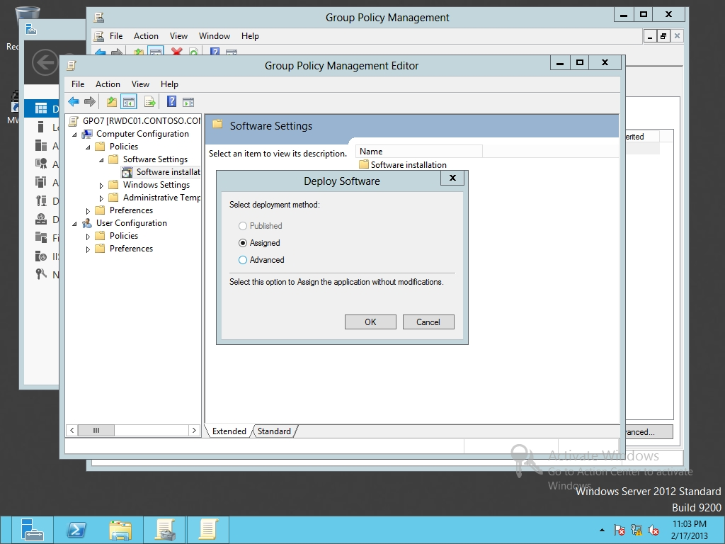

Figure 20-1

Selecting a deployment method

**8.** Keep the Group Policy Management Editor window open for the next exercise.

End of exercise. You can leave the windows open for the next exercise.

|  |  |  |
| --- | --- | --- |
| Exercise 20.2 | | Using Folder Redirection |
| Overview | During this exercise, you create a UserData folder on a server and redirect the user’s Documents folder to the UserData folder. | |
| Completion time | 10 minutes | |

**Mindset Question: You are thinking of using folder redirection for all documents stored in the Documents folder. What is the advantage of having all the Documents for the users in one location?**

**1.** Log in to Server01 as the **Contoso\Administrator** user account with the password of **Password01**. The Server Manager console opens.

**2.** On Server01, create the C:\UserData folder.

**3.** Right-click the C:\UserData folder and click Properties. The Properties dialog box opens.

**4.** Click the Sharing tab and click Advanced Sharing. The Advanced Sharing dialog box opens.

**5.** Click Share this folder. Click Permissions. Click Allow Change permission for Everyone

**6.** Take a screen shot of the Permissions for UserData dialog box by pressing Alt+Prt Scr and then paste it into your Lab20_worksheet file in the page provided by pressing Ctrl+V.

**7.** Click OK to close the Permissions for UserData dialog box and click OK to close the Advanced Sharing dialog box.

**8.** Click Close to close the UserData Properties dialog box.

**9.** On RWDC01, using Group Policy Management Editor for GPO7, navigate to the \User Configuration\Policies\Windows Settings\Folder Redirection node.

**10.** Right-click the Documents folder in the left window pane and select Properties. The Documents Properties dialog box opens as shown in Figure 20-2.

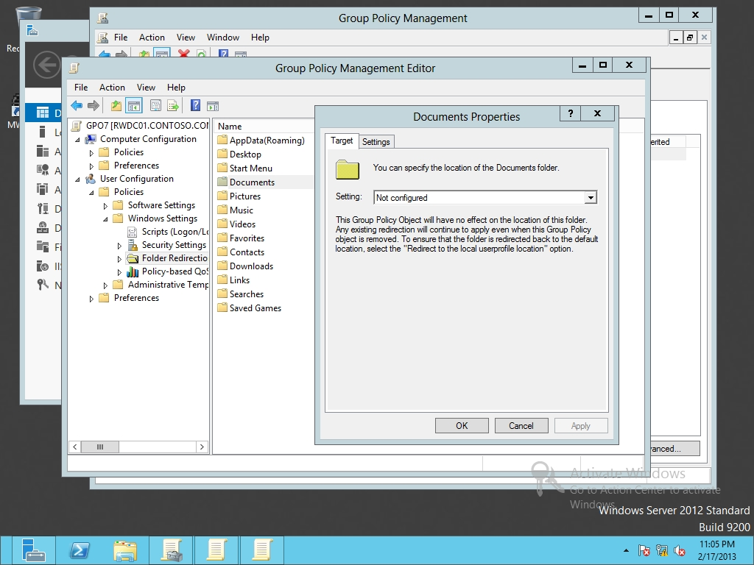

Figure 20-2

Redirecting the Documents folder

**11.** Under Setting, click *Basic – Redirect everyone’s folder to the same location* as shown in Figure 20-3. Under Root Path, type **\\server01\UserData**.

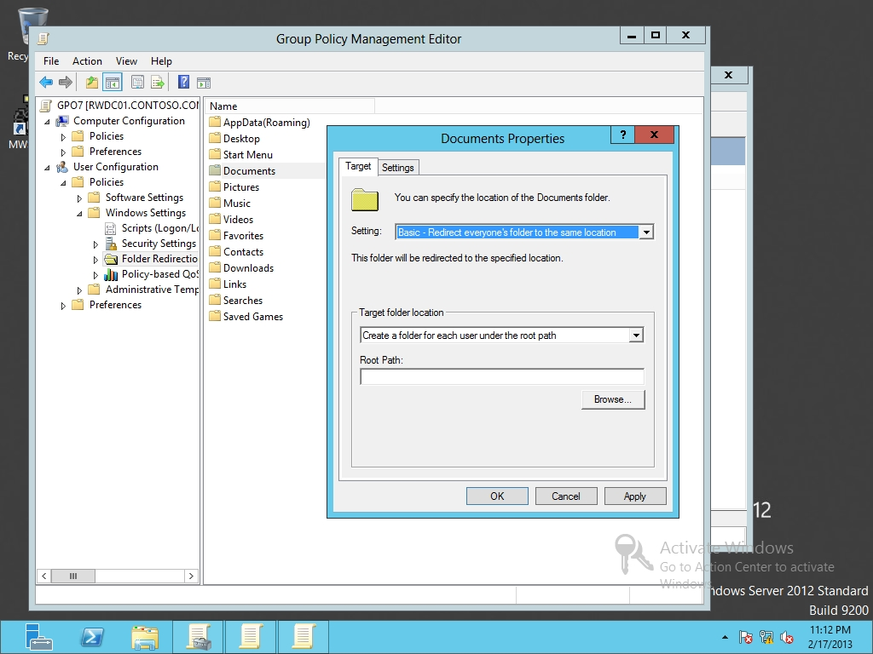

Figure 20-3

Selecting basic redirect

|  |  |
| --- | --- |
| Question 3 | If JSmith logs in, where would his Documents folder be located? |

**12.** Click OK to close Documents Properties dialog box. If a warning appears asking if you want to continue, click Yes.

**13.** Keep the Group Policy Management Editor window open for the next exercise.

End of exercise. You can leave the windows open for the next exercise.

|  |  |
| --- | --- |
| Exercise 20.3 | Using Scripts with Group Policies |
| Overview | During this exercise, you create a simple login script that will map the M drive to a shared folder and display "Hello" on the screen. |
| Completion time | 10 minutes |

**Mindset Question: List and explain the differences between the various scripts that you can execute with group policies.**

**1.** On Server01, open the C:\Data folder.

**2.** Open the View menu and click File name extensions check box.

**3.** Take a screen shot of the Data windows showing the File name extension option window by pressing Alt+Prt Scr and then paste it into your Lab20_worksheet file in the page provided by pressing Ctrl+V.

**4.** Right-click the empty white part of the C:\Data folder, click New, and click Text Document. For the name, highlight the entire filename, type **Hello.bat** and press the Enter key. If it asks are you sure you want to rename the file, click Yes.

**5.** Right-click Hello.bat and click Edit. Notepad opens.

**6.** Type in the following text:

**@echo off**

**rem The NET Use command will map the \\Server01\Data rem share to the M drive.**

**net use m: \\Server01\Data**

**echo HELLO**

**pause**

**7.** In Notepad, open the File menu and click Exit. When it asks to save the changes, click Save.

**8.** On RWDC01, using Group Policy Management Editor for GPO7, navigate to and click *User Configuration\Policies\Windows Settings\Scripts (Logon/Logoff)*.

**9.** Double-click Logon to open the Logon Properties dialog box, as shown in Figure 20-4.

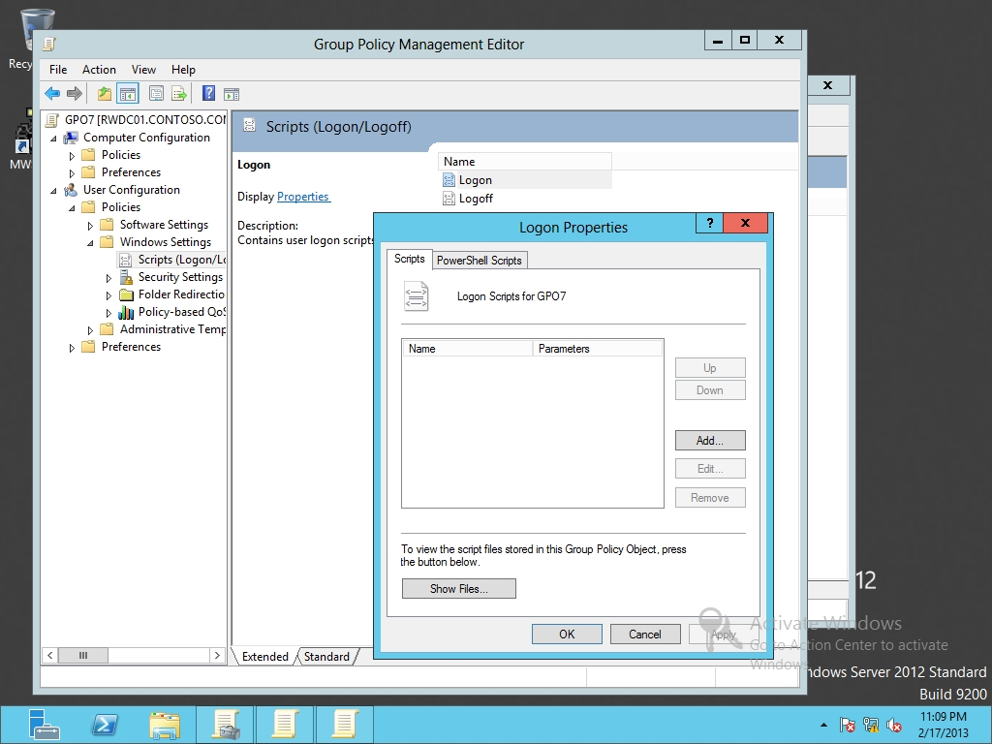

Figure 20-4

Configuring Logon scripts

**10.** Click Add to open the Add a Script dialog box.

**11.** In the Script Name text box, type **\\Server01\Data\Hello.bat** and click OK. Click OKto close the Logon Properties dialog box.

**12.** Keep the Group Policy Management Editor window open for the next exercise.

End of exercise. You can leave the windows open for the next exercise.

|  |  |
| --- | --- |
| Exercise 20.4 | Using Administrative Templates |
| Overview | During this exercise, you configure the desktop wallpaper and screen saver settings. The screen saver settings are used to help protect a system by activating a screen saver when a user walks away from his or her computer for more than 15 minutes. If the screen saver is activated, the user will have to input his or her password to resume. |
| Completion time | 10 minutes |

**Mindset Question: What is used to define administrative templates when used with group policies?**

**1.** On RWDC01, using Group Policy Management Editor for GPO7, navigate to and click User Configuration\Policies\Administrative Templates\Desktop\Desktop.

**2.** Double-click Desktop Wallpaper. The Desktop Wallpaper dialog box opens.

**3.** Click Enabled. Then in the Wallpaper Name, type the following:

**C:\Windows\Web\Screen\img101.jpg**

**4.** Take a screen shot of the Desktop Wallpaper dialog box by pressing Alt+Prt Scr and then paste it into your Lab20_worksheet file in the page provided by pressing Ctrl+V.

**5.** Click OK to close the Desktop Wallpaper dialog box. The Desktop Wallpaper shows as Enabled.

**6.** Navigate to and click User Configuration\Policies\Administrative Templates\Control Panel\Personalization.

**7.** Double-click Enable screen saver. The Enable screen saver dialog box opens.

**8.** Click Enabled and click OK to close the Enable screen saver dialog box.

**9.** Double-click Force specific screen saver. The Force specific screen saver dialog box opens.

**10.** Click Enabled. In the Screen Saver executable name, type **scrnsave.scr**. Click OK to close the Force specific screen saver.

**11.** In the Personalization node, double-clickScreen saver timeout.

**12.** Click Enabled. Answer the following question. Then click OK to close the Screen saver timeout dialog box.

|  |  |
| --- | --- |
| Question 4 | What is the default number of seconds? |

**13.** Lastly, double-click Password protect the screen saver. The Password protect the screen saver dialog box opens.

**14.** Click Enabled. Click OK to close the Password protect the screen saver dialog box.

**15.** Close the Group Policy Management Editor window.

End of exercise. You can leave the windows open for the next exercise.

|  |  |
| --- | --- |
| Exercise 20.5 | Using Security Templates |
| Overview | During this exercise, you open a security template for domain controllers and use it to compare settings with RWDC01. |
| Completion time | 10 minutes |

**Mindset Question: Why are security templates used and how are they used with group policies?**

**1.** On RWDC01, right-click the Start menu and select Command Prompt (Admin).

**2.** At the command prompt, execute the mmc command. An empty console opens.

**3.** Open the File menu, and click Add/Remove Snap-in.

**4.** When the Add or Remove Snap-ins dialog box opens, scroll down and click Security Templates. Click Add. Click OK. The Security Templates snap-in is available.

**5.** Select the Security Templates snap-in in the left pane. Open the Action menu and click New Template Search Path. When the Browse For Folder dialog box opens, navigate and click the following folder:

C:\Windows\security\templates

**6.** Take a screen shot of the Console1 Security Templates windows and Browse For Folder dialog box by pressing Alt+Prt Scr and then paste it into your Lab20_worksheet file in the page provided by pressing Ctrl+V.

**7.** Click OK to close the Browse for Folder dialog box. In the MMC console, double-click C:\Windows\security templates, and then double-click the DC security template.

**8.** Browse the various settings. Be sure to view the System Services.

**9.** Close the MMC console. When prompted to save the console, click No.

**10.** Back at the command prompt, execute the mmc command again. An empty console opens.

**11.** Open the File menu, and click Add/Remove Snap-in.

**12.** When the Add or Remove Snap-ins dialog box opens, scroll down and click Security Configuration and Analysis. Click Add. Click OK. The Security Configuration and Analysis console is available.

**13.** Right-click Security Configuration and Analysis in the left pane and click Open Database. In the File name text box, type **Test** and click Open.

**14.** When it asks to import template, in the file name text box, enter the following and click Open:

**C:\Windows\security\templates\DC security.inf**

**15.** Right-click Security Configuration and Analysis and click Analyze Computer Now. When the Perform Analysis dialog box opens, click OK.

**16.** When the analysis is done, check the settings looking for settings that are not compliant, including Startup and Permissions settings in System Services.

**17.** Close the Security Configuration and Analysis console, clicking No so that you do not save the console.

Lab REview Questions

|  |  |
| --- | --- |
| **Completion time** | **10 minutes** |

**1.** In Exercise 20.1, what type of programs can you install with a GPO?

**2.** In Exercise 20.1, when you deploy software with group policies, which option allows you to automatically install software when the user clicks the application icon or when a user tries to open a file that is associated with the specified application?

**3.** In Exercise 20.2, if you decide to redirect the Document folder, what other folder should you consider to redirect for users that might also have user documents?

**4.** In Exercise 20.3, list some of the types of scripts that you can execute with GPOs?

**5.** In Exercise 20.4, what is used to customize a user’s Windows look and feel?

**6.** In Exercise 20.5, what is used to check security settings of a computer running Windows Server 2012?

|  |  |
| --- | --- |
| Lab Challenge | Using ADM Files |
| Overview | To complete this challenge, you must demonstrate how to install and use the ADMX Migrator by writing the steps to complete the tasks described in the scenerio. |
| Completion time | 15 minutes |

Write out the steps you performed to complete the challenge.

End of lab. You can log off or start a different lab. If you want to restart this lab, you’ll need to click the End Lab button in order for the lab to be reset.